**A La Nina-like climate trend: natural variability or externally forced**

Dong-Ping Wang[1],[2], Dake Chen1, Minghua Zhang2

submitted to *Nature Climate Change*

email: dong-ping.wang@stonybrook.edu

The rise of global mean temperature has taken a hiatus since 2000. Meanwhile, the equatorial Pacific is experiencing a climate trend of decreasing (increasing) sea surface temperatures (SST) in the east (west) and increasing trade winds1,2. Recent climate model experiments attributed the hiatus to a La Nina-like climate trend; the latter is thought to be a natural variability associated with a cold phase of the Pacific Decadal Oscillation (PDO) (or Interdecadal Pacific Oscillation; IPO)3,4. Here we suggest that the observed La Nina-like condition of cooling (warming) in the eastern (western) Pacific is externally forced. Moreover, the observed SST and trade wind patterns are consistent with an 'ocean thermostat feedback' mechanism5. We also present tentative evidence of a La Nina-like climate trend from the Coupled Model Intercomparison Project (CMIP5). Our study highlights the role of ocean dynamics in regulating Earth's climate system. It also raises an intriguing question about potential connections between natural variability and external forcing.

We analyze global SST patterns from 1950 to 2013, covering a full 'cycle' of PDO to avoid bias by a persistent (20-30 years) warm or cold phase6. The analysis is restricted to recent warming to minimize the issue that the externally forced response might not be stationary. The evolution of global mean SST since1950 can be divided into three epochs, an extended hiatus that ends at 1975, accelerated warming between 1976 and 2000, and the current hiatus (Fig. 1). In addition to the secular trend, global mean SST is punctuated by large interannual variability associated with El Nino - Southern Oscillation (ENSO). The 1997/1998 El Nino, for example, stands out as the warmest period on record.

We use an extended empirical function analysis (EEOF) with a 5-season window to decompose global SST into a set of identifiable patterns (see Methods). EEOF is the same as the commonly used EOF, but allowing for time-varying spatial patterns. The first two modes explain about 33% of the total global SST variance, but account for 94% or practically all of the global mean SST. In other words, the global mean is determined primarily by patterns of the largest spatial scales. The first mode is a global manifestation of the canonical El Nino, marked by a large warming in the tropical central-eastern Pacific and a strong cooling in the extratropical North Pacific (Supplementary Fig. 1)6. There are also delayed warming in the Indian and Atlantic Oceans. The corresponding principal component (PC) mirrors the cold tongue (CT) index (or Nino-3.4) (Supplementary Fig. 2). We note that there is an abrupt upward shift of the first PC in 1976, corresponding to the well documented 'regime shift' in the North Pacific7,8.

The adjusted global mean SST, after removing the canonical ENSO, reflects primarily an externally forced response. Since the second PC is basically the same as the adjusted time series (γ = 0.91), it will be called a 'forced mode' to contrast with the ENSO mode of natural variability. The forced mode nevertheless contains significant interannual variability of 'non-canonical' ENSO signals. Prior to the regime shift, the original and adjusted time series are offset by about 0.1 oC of the baseline (Fig. 1). After the transition, the two time series rise together. The original time series has a much steeper warming trend during the accelerated warming epoch, whose appearance though is shaped somewhat by the two extreme end members, a regime shift in the beginning and a super El Nino near the end. After removing major interannual variability, the adjusted time series shows a constant warming trend of about 0.056 ± 0.012 oC per decade (95% confidence interval). This indicates that the externally forced SST warming has not abated even during the recent hiatus. In other words, the hiatus could in part be attributed to diminishing El Nino activities (Supplementary Fig. 2).

The forced mode has a La Nina-like pattern (Supplementary Fig. 1). Averaged over 5 seasons, the spatial pattern shows a general cooling in the eastern Pacific concentrated in a narrow band between 5oS-5oN, and a widespread warming spanning from the tropical western Pacific to the extratropical central North and South Pacific (Fig. 2). This pattern differs substantially from a La Nina (the cold phase of the ENSO mode) which has a broad cooling in the eastern Pacific, between 20oS-20oN, but a restricted warming mainly in the extratropical North Pacific. The sea level pressure (SLP) patterns from regressing to the second PC also indicate a La Nina-like response (Supplementary Fig. 3). The large east-west SLP gradient is characteristic of the Southern Oscillation (Fig. 3). The meridional SLP gradients, on the other hand, are relatively weak. In contrast, during a La Nina, SLP anomalies have large amplitudes over the Gulf of Alaska9. Also, easterly anomalies are shifted westward, consistent with a cold anomaly centered at about 160oW10.

The spatial patterns of SST, SLP, and trade winds of the forced mode agree well with the La Nina-like decadal trends1,4,10. This is quite remarkable considering that the forced mode explains only about 14% of the total SST variance. We note that the cooling trend in the eastern Pacific is often attributed to a cold phase of PDO3,4. PDO and canonical ENSO are highly correlated (γ = 0.80). (PDO is defined as the leading EOF mode of SST anomalies in the North Pacific, after removing the global mean6.) The PDO pattern is similar to a La Nina with cooling in the eastern equatorial Pacific, negligible warming (cooling) in the western equatorial Pacific (Indian Ocean), and strong warming in the extratropical North Pacific6,11. The corresponding SLP pattern is also like a La Nina. These features differ substantially from the observed decadal trend. Indeed, the differences of SST, SLP, and trade winds between the warm (1976-1998) and cold (1999-2012) phases of PDO have much more in common with the forced mode than with PDO11.

To have cooling in the eastern equatorial Pacific under a uniform radiative heating suggests strong feedbacks between the tropical ocean and atmosphere. One such mechanism is an ocean dynamical thermostat5. In the equatorial Pacific, the thermocline shoals eastward. In the west, surface warming responds directly to surface heating. In the east, because of a shallow thermocline, surface warming however is offset by cold upwelling, producing a smaller temperature increase. Consequently, there will be an east-west SST gradient which through the Bjerknes feedback, could lead to a La Nina-like pattern comparable to the forced mode. Moreover, a strong La Nina-like climatology might suppress El Nino events12. This is also consistent with diminishing El Nino activities during the current hiatus (Supplementary Fig. 2). The connection is gratifying, which however could be entirely coincidental because of the relatively short record.

No climate model in CMIP5 appears to have reproduced the observed La Nina-like trend4,13. We are however most interested in knowing whether coupled climate models could capture a La Nina-like feature. An extensive search of all climate models is beyond the scope of this study. Instead, we focus on one single model, the Community Climate System Model Version 4 (CCSM4) of National Center for Atmospheric Research (NCAR). There are 6 historical runs included in CMIP5, and all predict a warming trend of about 0.14 oC per decade between 1965 and 2000. In the model, the accelerated warming starts in the mid-1960s, about a decade ahead of the observations. A La-Nina like climate trend is found only in one case, r2i1p1, whose third mode shows a strong cooling in the eastern Pacific in the midst of a broad warming (Supplementary Fig. 4). Indeed, the 5-season averaged SST pattern is quite similar to the forced mode (Fig. 4). Moreover, the warming trend, 0.074 ± 0.020 oC per decade, is also comparable to the observed. However, unlike the observations, El Nino activities are enhanced (Supplementary Fig. 5). It is well known that in coupled climate models the Walker circulation is weakened under anthropogenic forcing14,15. We note that enhanced El Nino activities nevertheless are also found in 3 other historical runs. This raises an interesting question whether by prescribing a La Nina-like climate trend which presumably encourages ocean thermostat feedback, recent model experiments might have suppressed other feedbacks inherent in the coupled climate model3,4. Alternatively, it might be argued that the ocean thermostat feedback perhaps is overlooked in a coupled climate model. To improve climate prediction, a better understanding of the interplay between ENSO and external forcing probably is needed.

**Methods**

We use the UK Met Office Hadley Centre's sea ice and sea surface temperature dataset, HadISST, a 1o × 1o high-resolution SST dataset reconstructed from in situ and satellite observations16. The gridded SSTs are area weighted by the square root of the cosine of latitude. We also use the National Centers for Environmental Prediction/National Center for Atmospheric Research (NCEP/NCAR) Reanalysis (2.5o × 2.5o) for sea level pressure and surface wind17. Seasonal means are computed from the monthly data, and the anomalies are formed by removing the seasonal cycle, the mean of each season. The analysis is over the entire globe between 70oS and 70oN with the original data resolution. For the EEOF analysis, we use a time window of 5 seasons18. A two-dimensional Principal Component Analysis is used19. We note that the EEOF results are consistent with the conventional EOF analysis. The 5-season-averaged spatial patterns of the first two EEOF modes are basically the same as the corresponding EOF modes.

**References**

1. McPhaden, M. J., T. Lee, and McClurg, D. El Nino and its relationship to changing background conditions in the tropical Pacific Ocean. *Geophys. Res. Lett*. **38,** L15709 (2011).

2. L'Heureux, M.L., S. Lee, and Lyon, B. Recent multidecadal strengthening of the Walker circulation across the tropical Pacific. *Nature Clim. Change* **3**, 571-576 (2013).

3. Kosaka, Y. and Xie, S-P. Recent global-warming hiatus tied to equatorial Pacific surface cooling. *Nature* **501,** 403-407 (2013).

4. England, M.H. et al. Recent intensification of wind-driven circulation in the Pacific and the ongoing warming hiatus. *Nature Clim. Change* **4**, 222-227 (2014).

5. Clement, A. C., R. Seager, M. A. Cane, and S. E. Zebiak. An ocean dynamical thermostat. *J. Clim.* **9,** 2190–2196 (1996).

6. Deser, C., M. A. Alexander, S.-P. Xie, and A. S. Phillips. Sea surface temperature variability: Patterns and mechanisms. *Annu. Rev. Mar. Sci.*, **2**, 115–143 (2010).

7. Mantua N.J, Hare S.R, Zhang Y, Wallace J.M, and Francis R. A Pacific interdecadal climate oscillation with impacts on salmon production. *Bull. Am. Meteorol. Soc.* **78**, 1069–79 (1997).

8. Zhang Y, Wallace J. M, Battisti D.S. ENSO-like interdecadal variability. *J. Clim.* **10**, 1004–20 (1997).

9. Alexander, M. A. et al. The Atmospheric Bridge: The influence of ENSO teleconnections on air-sea interaction over the global oceans. *J. Clim*. **15**, 2205-2231 (2002).

10. Chung, P-H. and Li, T. Interdecadal relationship between the mean state and El Nino type. *J. Clim*.**26**, 361-379 (2013).

11. Trenberth, K. E. and J.F. Fasullo. An apparent hiatus in global warming. *Earth's Future*, **1**, 19-32 (2013).

12. Mann, M.E., M.A. Cane, S.E. Zebiak, and A. Clement. Volcanic and solar forcing of the tropical Pacific over the past 1000 years. *J. Clim.* **18,** 447-456 (2005).

13. Fyfe, J. C., Gillett, N. P. & Zwiers, F.W. Overestimated global warming over the past 20 years. *Nature Clim. Change* **3,** 767-769 (2013).

14. Held, I. M., and B. J. Soden. Robust responses of the hydrological cycle to global warming. *J. Clim.* **19**, 5686–5699 (2006).

15. DiNezio, P.N., G.A. Vecchi, and A.C. Clement. Detectability of changes in the Walker circulation in response to global warming. *J. Clim.* **26**, 4038-4048 (2013).

16. Rayner, N. A. et al. Global analyses of sea surface temperature, sea ice, and night marine air temperature since the late nineteenth century. *J. Geophys. Res*. **108**, 4407 (2003).

17. Kalnay, E., et al. The NCEP/NCAR 40-Year Reanalysis Project. *Bull. Amer. Meteor. Soc.,* **77,** 437–471 (1996).

18. Guan, B. & Nigam, S. Pacific sea surface temperatures in the twentieth century: An evolution-centric analysis of variability and trend. *J. Clim*. **21**, 2790-2809 (2008).

19. Ye, J. Generalized low rank approximations of matrices. *Machine Learning*, **61**, 167-191 (2005).

**Acknowledgements**

DPW and DC are supported by grants from National Key Basic Research Program of China (2013CB430302) and National Natural Science Foundation of China (91128204). MZ is supported by the National Science Foundation and the Office of Biological and Environmental Research of the Department of Energy.

**Author contributions**

The author contributed to all aspects of the work presented in this paper.

**Additional information**

Supplementary information is available in the online version of the paper.

**Competing financial interests**

The author declares no competing financial interests.

**Figure legends**

Figure 1. Global mean sea surface temperature anomalies of original (red) and adjusted (blue) time series, and the slope for the adjusted time series (blue dashed). The vertical lines mark the boundaries between epochs.

Figure 2. SST pattern of the forced mode averaged over five seasons. The amplitude is normalized.

Figure 3. SLP and surface wind pattern of the forced mode averaged over five seasons. Winds are shown only for regressions significant above the 95% confidence interval. The area south of 50oS is blocked because SLP is off the scale.

Figure 4. SST pattern of a La Nina-like mode from CCSM4 historical run averaged over five seasons. The amplitude is normalized.

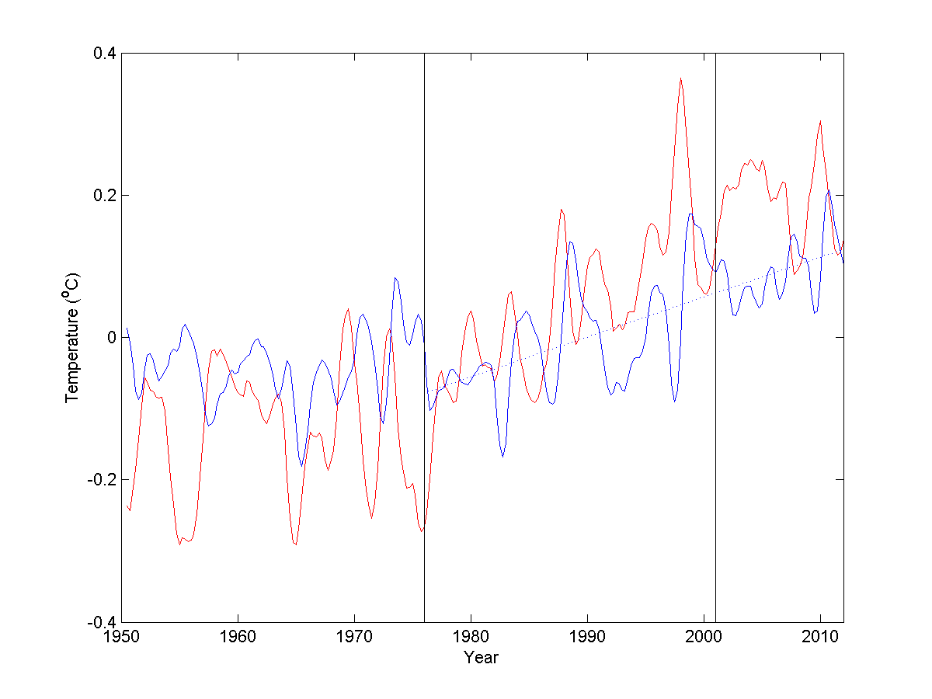

Figure 1. Global mean sea surface temperature anomalies of original (red) and adjusted (blue) time series, and the slope for the adjusted time series (blue dashed). The vertical lines mark the boundaries between epochs.

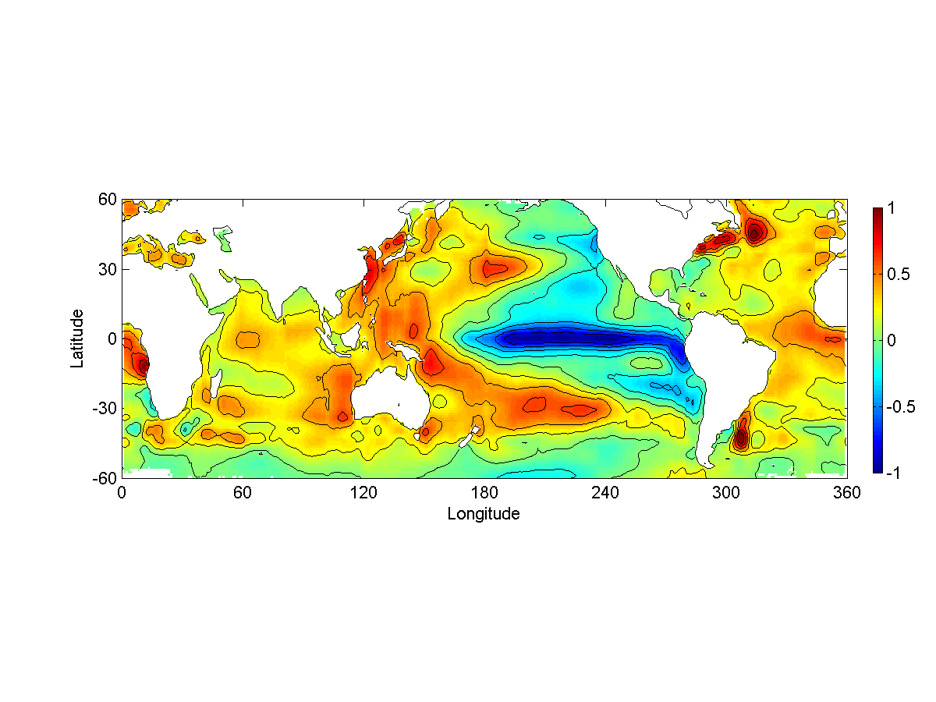

Figure 2. SST pattern of the forced mode averaged over five seasons. The amplitude is normalized.

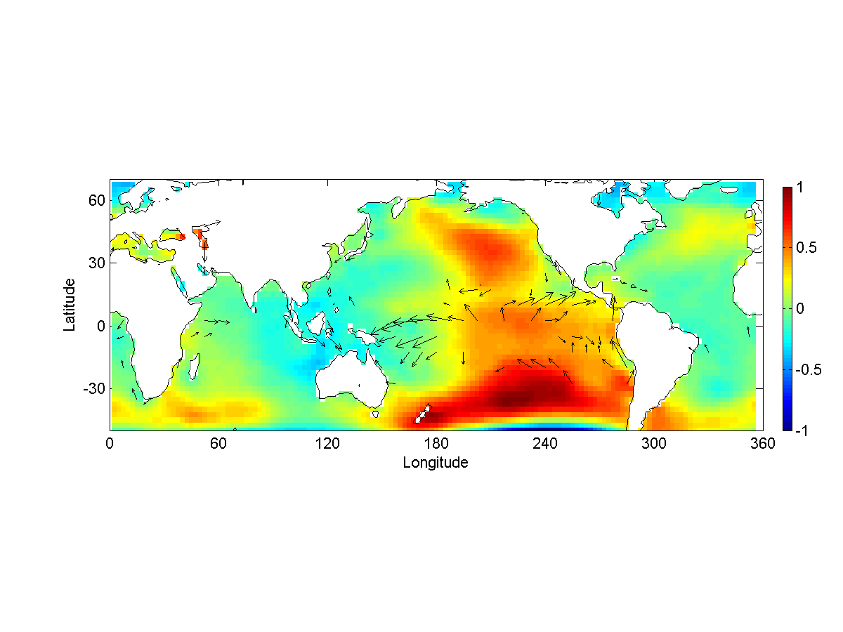

Figure 3. SLP and surface wind pattern of the forced mode averaged over five seasons. Winds are shown only for regressions significant above the 95% confidence interval. The area south of 50oS is blocked because SLP is off the scale.

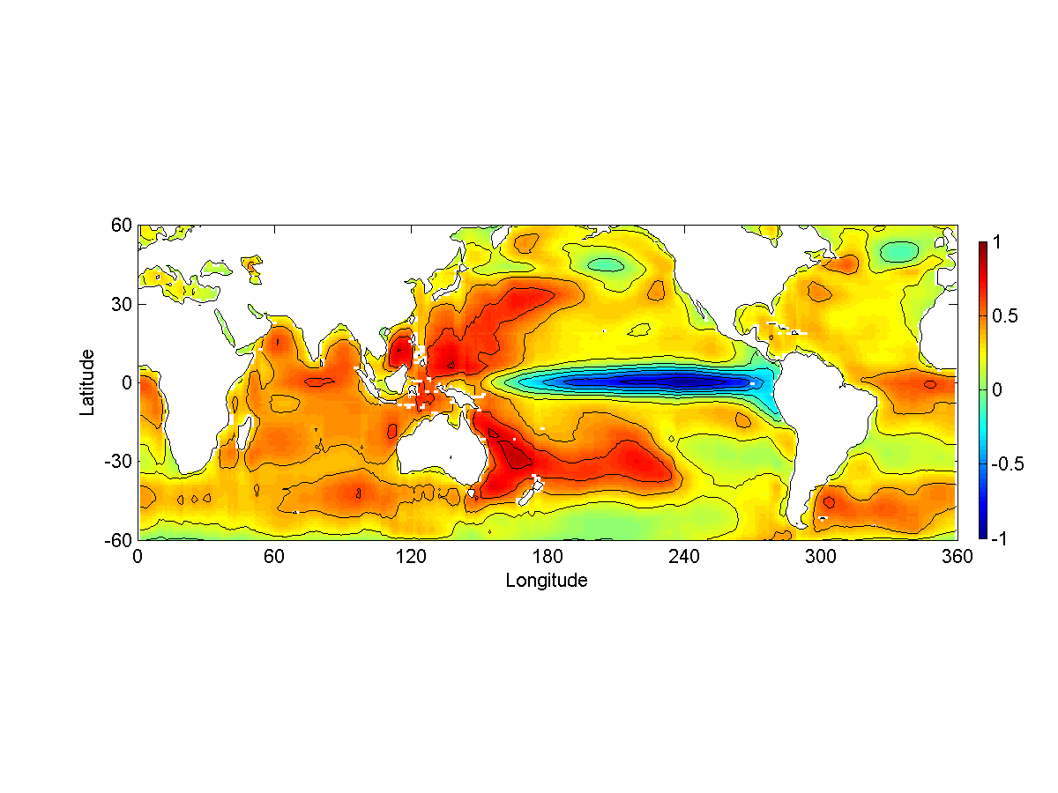

Figure 4. SST pattern of a La Nina-like mode from CCSM4 historical run averaged over five seasons. The amplitude is normalized.

1. State Key Laboratory of Satellite Ocean Environmental Dynamics, Second Institute of Oceanography, Hangzhou, China
2. School of Marine and Atmospheric Sciences, Stony Brook University, Stony Brook, New York, USA